**Task 1: - 07-03-2025**

1. Created a new folder and added two new files to it.

and concatenated them using the `cat` command with the `>>` operator 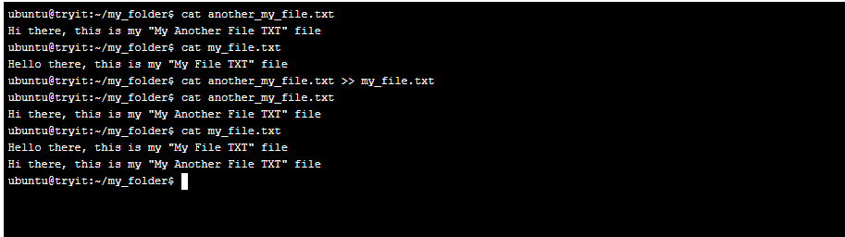

2. I created 20 text files in a folder, then renamed the first five files from .txt to .yml using mv command. After that, I used the touch command to update the timestamps of those five files, ensuring they appeared at the top of the long listing.



